AACS2284 Operating Systems

**Practical 4 – Managing Linux Jobs and Processes:**

1. Which of these statements apply to a *daemon process*?

a) A structured set of commands stored in an executable file on a Linux file system.  (Program)

b) A program that is loaded into memory and executed by the CPU. (Process)

c) A process launched by a user that is started from a terminal or within the graphical environment. (User process)

d) A system process that is not associated with a terminal or within the graphical environment.

2. Which of these processes starts one or more other processes?

a) Parent process

b) Child process (A process started by the parent process/another process)

c) Sibling process (The process started by the same parent process)

d) Zombie process (The process that has completed execution ***(via the exit system call)*** but still has an entry in the process table)

3. The first process that is started by the Linux kernel is the___________daemon.

a) Bash shell (After login)

b) kernel (Core of the Linux OX)

c) init

d) login  (After init daemon)

4. The kernel has a PPID of ____.

a) 0

b) 1

c) 2

d) 3

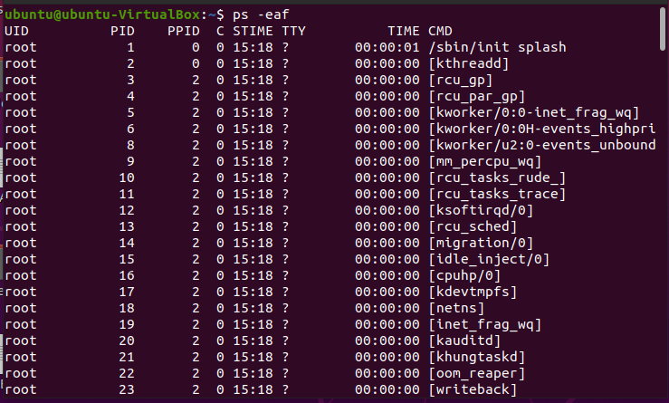

5. Write the **cron** entries for each of the scheduling requirement below:

a. Run the shell script /home/admin/backup.sh on January 2 at 6:15 A.M:

15 06 02 1/Jan * /home/admin/backup.sh

Crontab -e

15 6 2 1 * ./home/admin/backup.sh

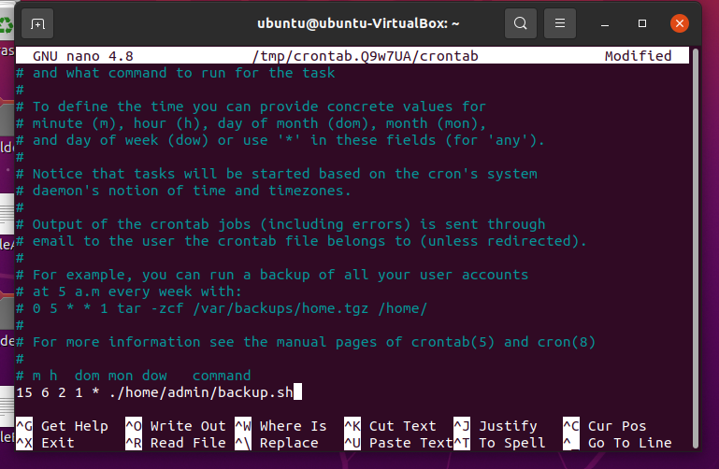

____________________________________________________________

b. Run the shell script /home/admin/backup.sh at 12:01 AM, every Monday in January:

crontab -e

1 00 * 1 1 ./home/admin/backup.sh

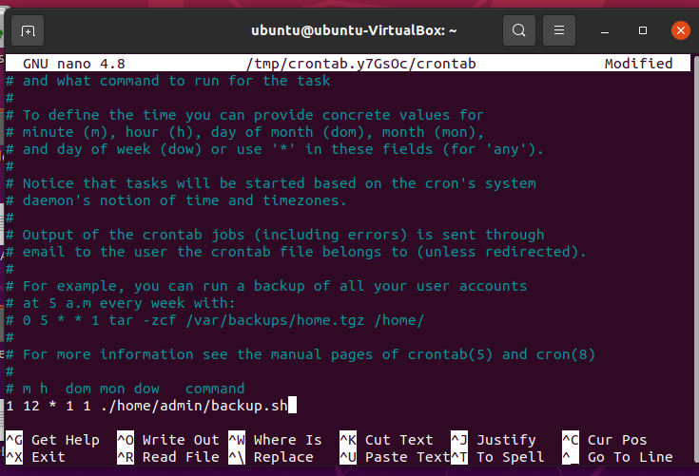

____________________________________________________________

c. Run /home/user/hourly-archive.sh every hour, on the hour, from 9 A.M. (09:00) through 6 P.M. (18:00), every day:

crontab -e

0 9-18 * * * ./home/user/hourly-archive.sh

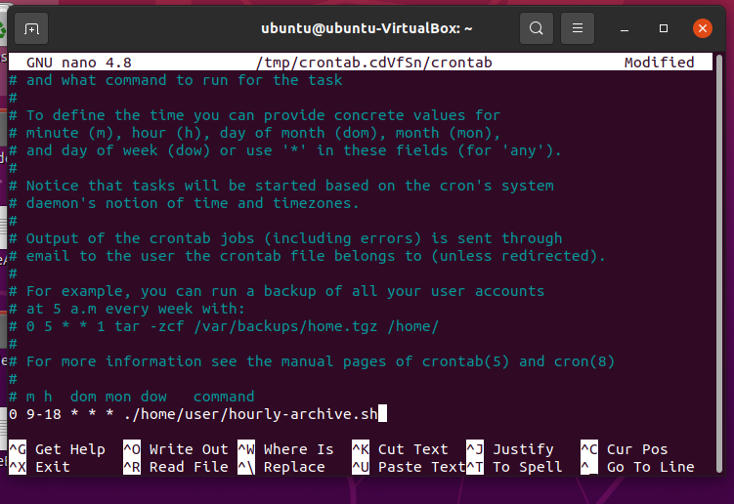

____________________________________________________________

d. Run **/**home**/**user/script.sh every Monday, at 9 A.M. and 6 P.M:

crontab -e

0 9,18 * * 1 ./home/user/script.sh

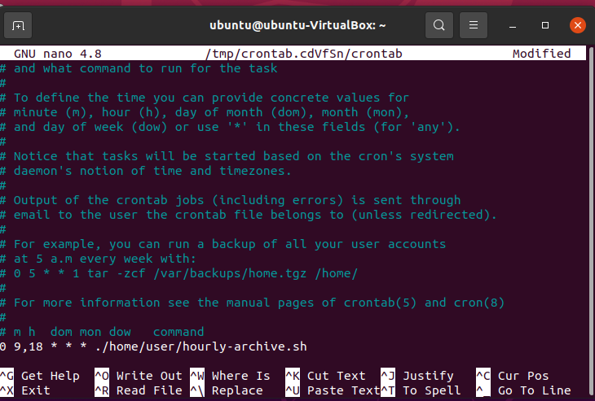

____________________________________________________________

e. Run /usr/local/bin/backup at 10:30 P.M., every weekday:

crontab -e

30 10 * * 1-5 ./usr/local/bin/backup

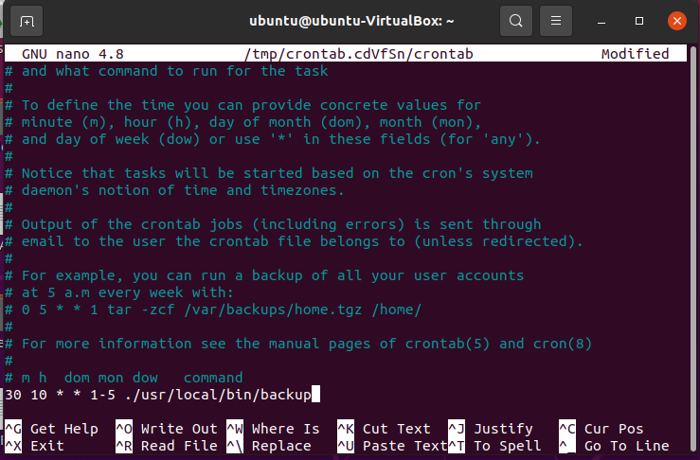

____________________________________________________________

1

AACS2284 Operating Systems

6. Write an ***at*** command to schedule each the command below to execute once in the future: a. Schedule a command to run immediately

At now

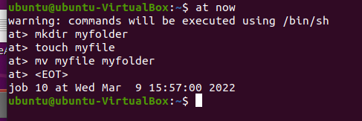

____________________________________________________________

b. Schedule a command to run at 4:00PM on the current date

at teatime

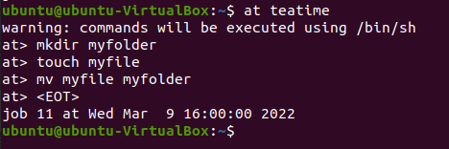

____________________________________________________________

c. Schedule a command to run at 9:00 AM on December 25th 2019

at 9:00am 12/25/2019



____________________________________________________________

7. Determine and explain when will a script be executed when placed into the respective cron folders below:

a. /etc/cron.hourly __To run job in hourly basis_______________

b. /etc/cron.daily __To run job in daily basis_______________

c. /etc/cron.weekly __To run job in weekly basis_______________

d. /etc/cron.monthly __To run job in monthly basis_______________

8. Write command(s) based on the following scenario:

a. To start an xeyes program and run it in the foreground _______xeyes____________

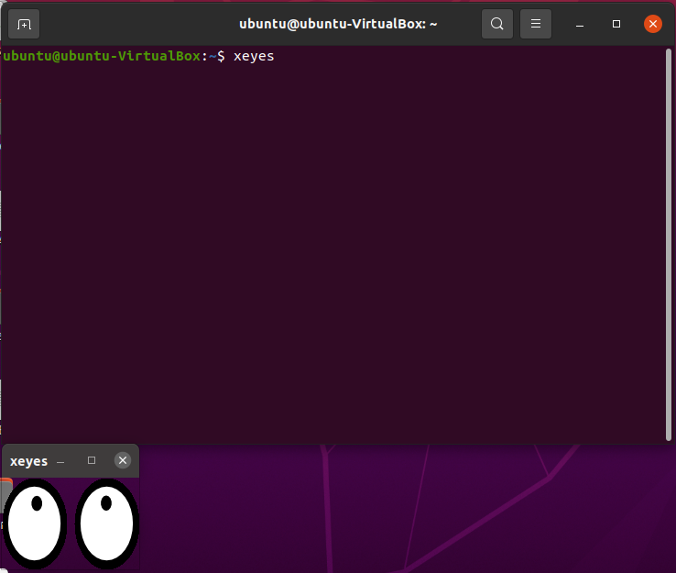

b. To start an xeyes program and run it in the background _______xeyes&__________

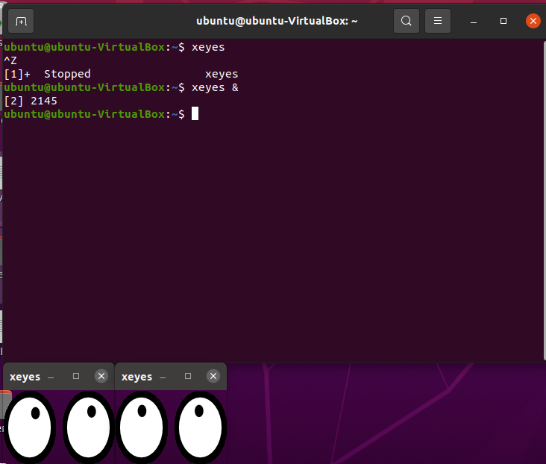

c. To stop a process that is running in the foreground ______control + Z_________ 

d. To list the contents of the job control _____jobs__________ 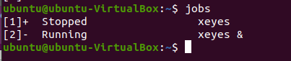

e. To edit your crontab file, or create one if it doesn’t already exist _______crontab -e________ 

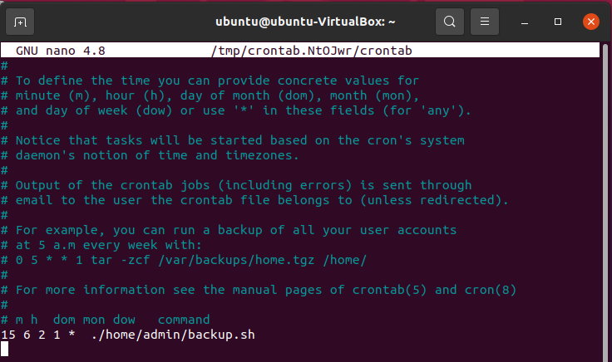

f. To display your crontab file ______ crontab -l_________ 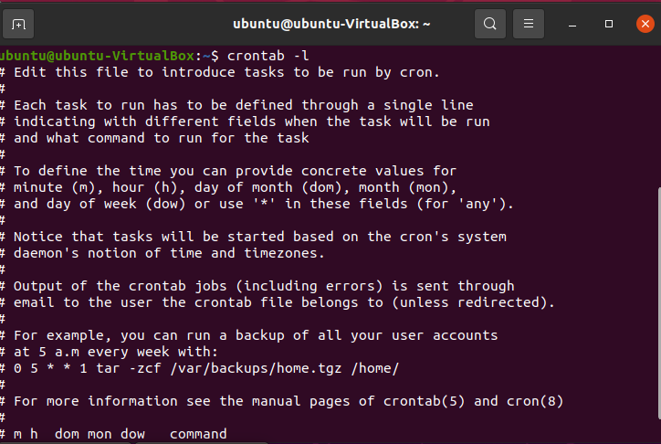

g. To remove your crontab file ______ crontab -r________ 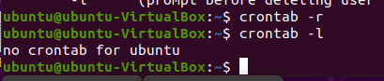

h. To display the last time you edited your crontab file ____crontab -v________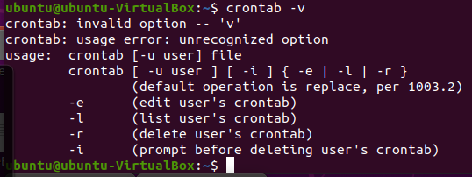

2

AACS2284 Operating Systems

9. Fill in the following UNIX commands:

|  |  |  |
| --- | --- | --- |
| **Command** | **Function** | **Note** |
| **bg** | To continue a stopped process in the background. |  |
| Fg job_ID | To switch a particular process running in the background to the foreground. |  |
| Ps a | To list all running processes. |  |
| pstree | To list processes in the form of a tree structure. |  |
| Nice -n ? job | To assign a process a specific priority value. |  |
| Renice ? PID | To change the priority value of a running process. |  |
| top | To view process information in a continuously updated list. |  |
| Kill PID | To terminate a process. |  |
| killall | To terminate all process. |  |
| sleep | To delay the start of a job. |  |
| nohup | To let a process to continue running even after you logout of the system. |  |

3

AACS2284 Operating Systems

**Extra exercises (Optional)**

|  |  |
| --- | --- |
| **1** | Write a command to create a variable “x” and assign the value “30” to this variable. **Answer: x = 30** |
| **2** | Issue a command so that the variable “x” created in Q2 can be accessed by sub-shells. **Answer: export x** |
| **3** | Issue a command to terminate a process with ID of 1234.  **Answer: kill 1234** |
| **4** | Write a command to execute a background process that displays a reminder to make a phone call in 20 minutes time.  **Answer**: **(sleep 20m ; echo “Reminder: Phone call”)&** |
| **5** | Write a command that will search for any file bigger than 100k, regardless of the user's connection to the terminal. The search results is to be saved to a file called “log.txt**”. Answer: nohup find -size +100k > log.txt** |
| **6** | Write a command to change the priority of the ***xeyes*** program (assume the process ID is 6578) from a default nice value (+10) to a nice value of -8.  **Answer: renice -8 6578 / renice -8 -p 6578 / renice -n -8 6578** |
| **7** | You are required to add a user ***cron*** job with the following requirements: - - Schedule the script in /usr/bin directory named updatedb to update your database regularly.  - The script is to be run every hour from 10:00 AM to 10:00 PM, Monday to Saturday. **Answer:**  **Crontab -e**  **0 10-22 * * 1-6 /usr/bin/updatedb** |

4